Intimate Hors D’oeuvres Menu - For Grove Cottage Only 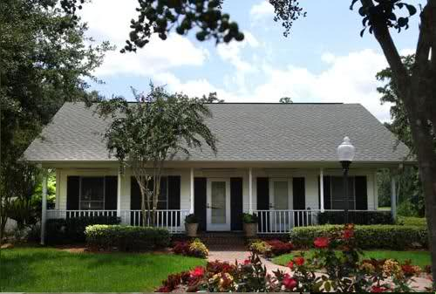
Your wedding will take place at the Estate House at Cypress Grove and then you will walk to the cottage for your wedding reception

For those not getting married at Cypress Grove but would like a reception at the Cottage please add $450.00 for 2 hour and $150.00 for each hour after the first two.

Receptions must end by 10pm.

The price for your wedding reception includes

Rental of the cottage for 2 hours
Professional event manager to oversee set-up and break-down
Complimentary white chairs for up to 20 guests for your reception
Complimentary onsite parking for guests
Tables
Table linens available for additional charge
Candy Buffet to end your wedding reception on a sweet note!

Reception Buffet to include:

Choice of Five (5) Hors D’oeuvres

Add additional items for $95/item up to 10 guests

BEVERAGE STATION
Water, Iced Tea, and Lemonade available at a self-service beverage station throughout the duration of your wedding.
Set-up to include:
Upscale Acrylic Disposable Plates & Flatware
Set-up of decorated Buffet Table
Attentive Service Staff including service a two (2) hour event

Choose any FIVE (5) Displayed Hors D’oeuvres
Cold hors d’oeuvres choices:

Duo of Bruschetta
Flavorful Bruschettas including Traditional Tomato and Tuscan White Bean Bruschetta served with Garlic Crostinis and Assorted Crackers
Thai Bridal Mix
An Exotic Mixture of Tomatoes, Celery, Peanuts, and Banana Chips tossed in a Tamarind, Ginger, & Passion Fruit Puree served with sliced Cucumbers

Fresh Fruit Display
Seasonal Fresh Fruit such as Melons, Berries, and Grapes artfully displayed for easy picking

Big City Cheese Board
A Selection of Elegant Cheeses to include Monterey Jack, Cheddar, Swiss, and Bleu Cheeses.
Garnished with assorted Crackers and Grapes.

Fresh Vegetable Crudité
Refreshingly Crisp & Colorful Array of Seasonal Vegetables served with creamy Garden Dill Ranch Dip

Raspberry Brie Cup
Raspberry Coulis topped with Almond Puree and Triple Cream Brie in a light and flaky Phyllo Cup

Caprese Skewer
Grape Tomatoes and petite Mozzarella Balls that are marinated in an Herb Vinaigrette and served on a skewer with a drizzle of sweet Balsamic Reduction

Pesto and Tomato Crostini
Toasted Baguette slices with Pesto Sauce, Diced Tomatoes, and Shredded Mozzarella Cheese baked to perfection

Chicken Apple Pastry
Chopped juicy Chicken tossed with Apple Cider, fresh Chopped Apples and Bleu Cheese. Topped with a Toasted Walnut and served in a pastry cup

Hot hors d’oeuvres choices:

Beef Chimichurri Skewers
Garlic and Cilantro marinated Skirt Steak skewered and served with a Chimichurri Vinaigrette

Twice Baked Potato Bites
Tender Twice-Baked New Potatoes fully loaded with Shredded Cheddar Cheese, Scallions, and Bacon Bits, topped with Cheddar Cheese

Hong Kong Spring Roll
A delicate Egg Roll Wrapper filled with a blend of Asian Vegetables then lightly fried and served with Mango Chili Sauce
Bourbon Chicken Bites
Tender Chicken Bites and Bell Pepper Squares served on a wooden skewer with Sweet Bourbon Glaze

Spinach Artichoke Phyllo Cups
Big City's famous Spinach Artichoke Dip consisting of Artichoke Hearts subtly blended with Spinach, Parmigiano-Reggiano, Cream Cheese, and served in a buttery Phyllo Cup.

Champignons Big City
Stuffed Mushrooms with our signature filling consisting of Roasted Garlic & Shallots, Artichoke Bottoms, Mushrooms, Sun-Dried Tomatoes, and Cream Cheese. This delicious filling is stuffed in a Buttered Mushroom Cap then topped with an Aged Parmesan Cheese and baked 'til perfect.
Greek Spinach Triangles
Crisp Buttery Pastry filled with Spinach and Feta Cheese then baked 'til golden brown

Seafood Fonduta
Seafood blended with Artichoke Hearts, Cream Cheese, and Parmesan Cheeses and served warm with Crostinis and Assorted Crackers.
Dessert- Candy Buffet Station – we provide the containers, candy and take home bags.
Upgrades available are:-
Table overlays
Bows on Chairs
Beer & Wine Bar
Beer, Wine and Spirits Bar
Kids meals
E mail for the latest prices
Have reception at the Estate House – additional costs for extra hours and subject to availability

