Cypress Grove Buffett – 2012
Within the two hour hire we have at the Estate House at Cypress Grove we can offer a small buffet set up – this is great for guests to have whilst the bride and groom are having photos taken or good to keep people going until lunch/dinner time
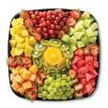
Fresh Fruit Platter to feed up to 12 people $40.00
Fresh Fruit Platter to feed up to 20 people $50.00
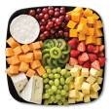
Fresh Fruit and Cheese Platter to feed up to 20 people $65.00

Finger Sandwiches – Cheese, chicken, egg or ham
To feed up to 12 people $36.00
To feed up to 20 people $45.00
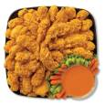
Chicken Tenders
Price available upon request, can feed up to 12 or up to 20 people
Soft Drinks Available by large bottle of individual cans – we can obtain the latest prices for you
Paper plates, cups and plastic cutlery included.
(We can get plates & Plastic cups in most wedding colors for an additional charge)
Other option is a Candy Buffet – which is a sweet way to end your wedding reception

